Keeping Students in Traditional Public Schools:
Collaborative Digital Augmentation of Curriculum in One High School English Course

Shanna Irving
EDRS 8000: Applied Quantitative & Qualitative Research
Kennesaw State University
December 7, 2014

Keeping Students in Traditional Public Schools:
Collaborative Digital Augmentation of Curriculum in One High School English Course
Dissatisfaction with public schools has led to the development of public charters. Conflicting research suggests that the educational excellence parents and students hope to find in charter schools may not be evident in impartial charter school performance data. For example, while some researchers promote charter schools as effective means of improving the education of charter school students and public school students in surrounding areas (Gray, 2012), other researchers renounce the available research on charter school effectiveness as predominantly biased and unrepresentative of the actual impact of charter schools on student learning (Knaak & Knaak, 2013). Some charter schools are populated via lottery: students enter the lottery in hopes of attending a school of choice. Recent research has demonstrated a positive correlation between lottery schools and educational attainment for female students, but a negative correlation was found between lottery schools and educational attainment for males (Deming, Hastings, Kane, & Staiger, 2014). Corroborating this research is a study by Hallinan and Kubitschek (2012) on female and male educational outcomes in Catholic schools: a significant increase in academic achievement was found for female students in Catholic school as compared to female students in public school, while male students in both school types demonstrated similar gains. These gains were slightly higher than the gains for female students in public school and significantly lower than the gains for female students in Catholic school.
Online schooling, too, has received its contradictory criticisms. It is argued that students who struggle with motivation in the traditional public school classroom demonstrate difficulty maintaining motivation in online schooling (Barbour & Skio, 2012). In contrast to this finding, research promoting collaboration in online schooling has demonstrated increased engagement and motivation for students (Gould, 2014).
Additional issues with the implementation of school choice programs include subterfuge between competing traditional and charter public schools (Foster, 2014), an imbalance between the supply and demand of school choice options (Hill, 2006), and “’over-cluttered’” (Pearcy, 2013, p.176) online course designs.
Despite conflicting evidence, the issues of charter schools selecting students in order to appear more effective (Knaak & Knaak, 2013), lottery-based and Catholic schools’ inability to engage boys in academically challenging curriculum (Deming, Hastings, Kane, & Staiger, 2014), and online schools’ potential to disengage learners who are considered at-risk (Siko, 2012), many parents and students remain dissatisfied with public school and seek out alternative options such as these (Butler, Carr, Toma, & Zimmer, 2013; Loeb, Valant, & Kasman, 2011). This study addresses a gap in the research by examining collaborative digitization as a means of increasing at-risk students’ enjoyment of public schools.
Statement of the Problem
The solution to the problems with charter, online school, and other choice school implementation may be best answered by returning to the discontent underlying the original development of these choice schools: offer dissatisfied students and their parents an alternative to traditional public schools. Arguably, the availability of alternative modes of education is not the answer; the answer may lie in revitalizing public schools in ways that will better engage all students’ minds and assuage their parents’ frustrations. The aim of this quantitative study is to determine whether collaborative digitization, when implemented effectively as augmentation to traditional public school classroom learning, has the potential to improve the traditional classroom education of all learners and to thus increase at-risk students’ desire to be there.
Research Questions and Hypothesis
This research seeks to answer the following questions: (1) Are at-risk students enrolled in a typical 9th grade Literature & Composition inclusion course more likely than their not at-risk peers to dislike public education?; (2) Can digital augmentation of a unit plan increase all students’ performance?; (3) Can digital augmentation of a unit plan increase at-risk students’ performance?; (4) Does an increase in performance align with an increase in overall desire to attend the school?; and (5) Does an increase in performance align with an increase in at-risk students’ desire to attend public school?
It is hypothesized that typically at-risk students and boys in collaborative digitally-augmented traditional public school 9th grade English will outperform typically at-risk students and boys enrolled in the same course without digital augmentation, as measured by numerical rubric data relating individuals from each group’s performance on a culminating unit assessment. It is further hypothesized that this success will increase at-risk students’ engagement with traditional public school and decrease their desire to attend alternative programs, as evidenced by a pre- and post-unit survey of student attitudes toward public school.
Theoretical Framework
This research is built upon the classical theory of social constructivism, which posits that people learn by constructing knowledge, or “making meaning” (Atherton, 2013), in collaboration with other people. The social constructivist theory is relevant to the hypothesis of this research, which seeks to determine quantitative support for collaboration-based digital augmentation of public school curricula.
Definition of Terms
Several terms are used in this study in research- and education-specific contexts. The term at-risk students is used to signify students who meet a specified set of criteria regarding motivation, family history, and personal history. In Cobb County, Georgia, students considered at-risk of failing are identified by truancy, disciplinary infractions, or teacher reports of academic difficulty (Field, 2011).
The term cherry-picking refers to the careful selection of students for a particular program. Charter schools have been accused of selecting and admitting only the best students to attend the school and thus skewing their performance data in their favor (Knaak & Knaak, 2013).
The term collaborative digital augmentation refers to the addition of a collaborative digital element to a traditional classroom approach to learning. This study relies on Vygotsky’s theory of social constructivism to support the hypothesis that collaborative digitization of traditional public school courses.
The term Community of Inquiry refers to a method of instruction that supports social construction of knowledge through questioning situations, concepts, and experiences (Swan, Garrison, & Richardson, 2009).
The term inclusion classes refers to classes that include students documented as having an academic disability. According to the U.S. Department of Education website ParentCenterHub.org, these include students with autism, deaf-blindness, deafness, developmental delay, emotional disturbance, hearing impairment, intellectual disability, multiple disabilities, orthopedic impairment, other health impairment, specific learning disability, speech or language impairment, traumatic brain injury, or visual impairment, including blindness (Alizo, 2014).
The term lemon-dropping refers to the performance-based intentional exclusion of students from a particular program. Charter schools have been accused of sending students who are underperforming away and thus skewing their performance data in their favor (Knaak & Knaak, 2013).
The term charter schools refers to schools that receive public funds but do not have to operate under school board policies. Charter school directors are free to implement whatever curricular, day-structuring, and classroom student/teacher ratio they desire.
The term traditional public schools refers to schools that are 100% publically-funded. They receive locally-determined amounts of money per student and, with school board oversight and within legal parameters, are mostly free to choose how to spend the money. They are typically cement-block structures with one classroom for each teacher amongst which students travel at specified times throughout the day. Traditional schools must adhere to all county school board policies and are not free to choose alternative forms of day structuring or academic testing.
Limitations and Delimitations
This study has several limitations. Because of the specifics of the population needed for the purposes of this study, only four classes of students will be studied. The relatively small sample size will thus be between 100 and 140 students, and the disaggregated data will reflect even smaller population samples. The participants are not taught by the same teacher; thus, an additional limitation is the possible impact of the differences in the two teachers’ styles and delivery. To mitigate the limitations, a survey instrument reliability-tested at an alpha coefficient of 0.85 in a previous study (Bibik, Goodwin, & Omega-Smith, 2007) will be used to assess the student’s attitudes towards the 9th grade Literature & Composition course before and after implementation of the treatment variable.
This study is delimited to the at-risk population that dominates the school choice market (Barbour & Siko, 2012) and has yet to find consistent academic gains in choice schools (Barbour & Siko, 2012; Grigg, 2012; Knaak & Knaak, 2013), the at-risk population is the focus of this study and students enrolled in advanced or gifted courses are excluded.
This study is also delimited to one unit of study, the Monster Odyssey Unit, in one course level, 9th grade, of one curricular area, Literature and Composition, a course taught at this level by both teachers who have each agreed take part in the study. Because this is the only unit the teachers will implement simultaneously, other units and courses are excluded. Accordingly, data collected to reflect student performance is delimited to assignments these teachers agree to both implement (see Appendices B, C, and D).
This research is delimited to a quantitative experimental method. Other research methods do not provide the comparative quantitative data needed to ascertain whether collaborative digitization increases student performance and desire to attend the school.
Significance of the Study
The intentions of this study are three-fold: (1) to add to the current research promoting collaborative construction of knowledge in the traditional public school classroom; (2) to inform the practice of local and national public school teachers; and (3) to call for systemic change that could both improve student performance and re-engage students and parents considering alternative education models.
Current research does not directly address how to change the dissatisfaction with traditional public school felt by the at-risk students and their parents who seek alternative school choices. This research will benefit public educators and administrators in providing support for digital augmentation of coursework and social constructivist collaboration for at-risk students. Results from this research will provide specific implications for future educational policy related to social constructivist learning and digital augmentation of traditional public school coursework.
Literature Review
A growing number of parents and students are dissatisfied with the education offered in traditional schools and are thus seeking alternatives (Deming, Hastings, Kane, & Staiger, 2014; Gray, 2012; Miller & Lassman, 2013). Many students seeking these alternative modes of education are considered at-risk (Barbour & Siko, 2012), but the preponderance of the research suggests that at-risk students’ performance suffers when they change schools (Grigg, 2012) and continues to suffer in both charter (Knaak & Knaak, 2013) and online school environments (Barbour & Siko, 2012). Re-engaging students and families in appreciation of traditional public schools may prove a better solution to the apparent inequities, as, some argue, examination of actual performance data may not support the notion that United States schools are “failing” at all (Farhi, 2012), and that the addition of alternative modes of education into the system may do significant harm (Grigg, 2012; Schwartz, 2009).
School Dissatisfaction as a Misunderstanding
Texas A& M University-Kingston professors Miller and Lassman (2013) lamented the tendency of public educators at the classroom, administrative, and political levels to weaken requirements, inflate grades and student egos, and essentially pass out unearned diplomas to under-educated, disenchanted students. Students and their parents echoed the concerns expressed by Miller and Lassman regarding traditional public schools, and in seeking other modes of education, have turned to charter schools and online schools.
These other modes of education exist on the premise that school dissatisfaction is both aligned with actual decreases in performance data and solvable by providing choice to parents for whom private school is not a viable option, but research has suggested that each of these premises is debatable (Farhi, 2012; Schwartz, 2009).
Farhi (2012) noted several areas in which United States public schools are increasingly successful: (1) significant increases in performance on comparable international assessments, and (2) a 46% increase in college attendance. Farhi also discussed the relatively new disaggregation of testing data into demographic categories, arguing that the previous method of determining the school’s performance in the aggregate may have simply masked the already-struggling students’ difficulties with performance. Thus, he asserted, schools have not worsened; the new presentation of the data has simply and more reliably demonstrated the equity issues that were already in existence.
Schwartz (2009) presented evidence from his own research and that of his peers, asserting that while some choice has a positive effect on motivation and achievement, “too many options seemed to produce paralysis rather than liberation” (p. 396). He attributed this paralysis to an association between increase in choice options and increase in regret over the choice once made, increase in anxiety about missing out on the other options, and increase in self-blame for any perceived difficulty facing the choice’s accompanying raised expectations. Citing an increase in the number of clinical depression diagnoses and suicides, he claimed that the increase in self-blame because of overwhelming choice could be, or could become, a contributing factor.
Charter Schools’ Conflicting Evidence
Overwhelming school dissatisfaction has led to the development of other schooling options in many communities. In some areas, charter schools are populated through a lottery system that requires students to select from the available schools then hope to be assigned to their first-choice school. The available research on lottery-based charter schools is limited. Deming, Hastings, Kane, & Staiger (2014) studied the impact of a lottery-based school program in North Carolina and provided evidence that a positive correlation with school choice via the lottery program and female student performance exists, and they posited that girls fare better in more rigorous academic environments. Their research suggests that boys, on the other hand, do not fare better, or even well, in challenging academic settings.
Knaak and Knaak (2013), however, posited that twenty years’ worth of charter school student performance data has yet to yield unequivocally positive results. They renounced the available research on charter school effectiveness as predominantly biased and unrepresentative of a comprehensive impact picture. They even asserted that evidence exists of charter schools “cherry picking [and] lemon dropping” (p. 49) students in order to inflate their academic performance data and to strengthen charter schools’ ability to attract the most highly-motivated and parent-supported students. The lack of governmental oversight or accountability measures in Minnesota, where charters began and are most widely integrated, they argued, has left Minnesota’s students no better off after the two decades of the charter school option throughout the state.
Hill (2006) highlighted contributing, even inhibiting, factors in order to explain the performance data disconnect between the idea of school choice and the actual implementation. The main issue, he argued, was the countrywide lack of alternative school choice supply, an issue exacerbated by difficulties such as low per-pupil funding, inequitable competition, unstable rules, uncertain access to facilities, unpredictable costs, and an entrepreneurial learning curve. He detailed the inequities in political treatments that show preference to traditional public schools, even scathingly accusing public school officials and vendors of intentional subterfuge and intrusive oversight measures meant to discover means of sabotaging choice schools’ financial capabilities. He further contended that the problems schools of choice face are the cause of the generally poor results those schools saw in terms of student achievement increases.
Booker, Sass, Gill, and Zimmer (2011) studied the differences in educational attainment between students in traditional high school settings as compared to charter settings. They contended that a voucher program for charter schools in the District of Columbia reflected significantly higher graduation rates and college attendance rates among students attending schools of their choice. They highlighted the commonalities between charter schools, Catholic schools, and the DC school voucher program in order to promote a school culture that supports student choice in education location and a vibrant landscape of education setting possibilities for middle and high school students.
Foster (2014) reported that charter schools continued to face external difficulties, such as that of location. Many charters, she claimed, resort to renting abandoned strip malls or sharing church houses with the churches’ congregations. Her research was more balanced than Hill’s (2006) and offered an updated perspective that, while highlighting that these problems still existed in February of 2014, also detailed the traditional public school supporters’ perspectives. Traditional public school supporters, she explained, did not recognize any subterfuge on their end, but saw charter schools as ungoverned, mishandled siphons of precious public funds. She ultimately concluded that a respectful and collaborative coexistence would benefit students, parents, and teachers in the long run.
While her vision may be ideal, a more practical, immediate approach may prove more beneficial to all students, particularly those that are disenfranchised by the school choice options. Male students (Deming, et al., 2014) and students considered at-risk (Barbour & Siko, 2012) constitute a large portion of the students who are dissatisfied with the traditional public classroom, and these same groups continue to fail despite the change in mode of education.
Online Schools’ Conflicting Evidence
Pearcy (2013) detailed his own experiences as a student, teacher, and professor in and of traditional face-to-face education as compared to online education and found significant value in online education, citing instructors’ increase in per-student accountability, the collaborative and interactive capabilities of effectively-implemented online education, and the increased opportunities for students to work independently and in greater depth. Likewise, Gould (2014) restructured the humanities course and reported great success and demonstration of depth of thinking that far surpassed any done in the preceding traditional public school curriculum format. She argued that digital humanities can be effectively integrated into any curriculum to great effect (Gould, 2014). The case study she presents on the effectiveness of this digitization of her curriculum supports her assertion that technology may be able to answer the initial concerns of pro-school/choice parents seeking alternative means of education.
Barbour and Siko (2012) sought qualitative case study data that would reflect the experiences of at-risk high school students enrolled in a supplemental online learning program. At-risk students, they assert, are a large population of online learners but are neglected in the research. Their findings suggest that students who struggle with motivation in the traditional public classroom struggle even more in online environments. Their research subject, nicknamed Kevin, demonstrated characteristics that aligned with this assessment. However, the lack of a collaborative or mentor element in Kevin’s experience with online education suggests that the methodology may be more to blame than Kevin’s status as an at-risk learner.
Still, Barbour and Siko’s findings are substantiated by Thompson, Miller, and Franz (2013), who collaborated on a qualitative case study analysis of three non-traditional students who failed one online education course and opted to repeat the course in a face-to-face setting instead. They associated the failure of the online courses with problems “inherent in online education” (Thompson, et al., 2013, p. 240): students who struggle to self-regulate in the classroom despite the support of educators and peers may find even greater difficulty self-regulating without the dedicated course time and extra supports. In order to alleviate those difficulties, the researchers supported the implementation of a Community of Inquiry model in which students socially construct knowledge.
Keeping Students in Public School
Social constructivist learning (Atherton, 2013) provides social support and encourages the self-regulation that Thompson, et al. (2013) discussed as lacking in online education environments. By implementing collaborative digitization, it is likely that educators can promote educational and social equity the at-risk students disenfranchised by both the current traditional public school methods and the school choice options available to them. Fernández and Valverde (2014) designed, implemented, and evaluated a Community of Inquiry-based training program for a typically underserved population of gypsy women in Rome, Italy. The researchers were careful to create an online learning environment that mimicked the “social processes of the building of knowledge that take place in the negotiation of meanings in the classroom” (Fernández & Valverde, 2014, p. 98). The researchers reported resulting positive educational and personal gains for the women.

Library Search
The research materials used for this proposal were gathered through a systematic search of Kennesaw State University’s library database for information relevant to dissatisfaction with public school, charter school and choice school effectiveness, and social constructivist teaching impact. The following search terms and variations on them were utilized by the researcher: “school dissatisfaction”; “charter school performance data”; “online school performance data”; “students attitudes survey”, “social constructivism engagement”.
Summary
Dissatisfaction with public school may be based on a misunderstanding of publicized performance data (Farhi, 2012) and of misrepresented or biased charter school performance data (Knaak & Knaak, 2013; Schwartz, 2009) that does not consistently demonstrate gains for male students (Deming, Hastings, Kane, & Staiger, 2014). Online education has not demonstrated academic gains for students considered at-risk (Siko, 2012), but the implementation of a Community of Inquiry (Thompson, et al., 2013) based on the theory of social constructivism (Atherton, 2013) as a means of digitally augmenting coursework (Gould, 2014; Pearcy, 2013) in traditional public schools may have the potential to re-engage at-risk students with the traditional public school environment. This research will seek to determine whether the digital augmentation of a unit of study in an inclusive 9th Literature & Composition course has a positive effect on at-risk students’ performance and desire to attend the school.
Methodology
Research Design
This study seeks to measure a quantifiable increase in performance data and in desire to attend traditional public school. A quantitative approach was selected in order to measure those increases. An experimental design will measure the treatment population’s results in relation to the non-treatment population’s results in order to determine a correlation between digital course augmentation and overall performance, digital course augmentation and at-risk student performance, digital course augmentation and overall desire to attend the school, and digital course augmentation and at-risk students’ desire to attend the school. As demonstrated in Appendix A, the control group in this study will learn the unit as taught without collaborative digital augmentation, and the treatment group will learn the unit as taught with collaborative digital augmentation.
Participants
Teacher assistance was determined by informal teacher interviews at the school where the research will be conducted. The participants include two volunteer teachers and their two classes of students each. The teachers teach multiple inclusion classes of the same course, 9th grade Literature and Composition, and two of the classes per teacher will encompass the participating students. The classes are inclusion classes that include 30 students each. Of the 30, at least 10 in each class are documented as at-risk for failure either through an Individualized Education Plan (IEP) or through teacher or administrator Response to Intervention (RTI) evaluation. The data will be disaggregated in order to determine the impact on the at-risk students specifically and compared to the data for those students not considered at-risk.
Instrumentation
Students in the control group will need access to a regular classroom and regular classroom materials, including but not limited to textbooks, paper, and writing utensils, during most school days, but access to the internet will also be required either via personal electronic devices or media center visits on some days. Students in the treatment group will also need access to iPads, laptops, smart phones, and Internet tools.
The pre- and post-unit survey (Appendix B) is a modified version of a survey used in previous related research by Bibik, Goodwin, and Omega-Smith (2007). The section relevant to this research was reliability tested at an alpha coefficient of 0.76 for section 1, 0.85 for section 2, and 0.96 for section 3. Modifications to befit this research were the omission of section 1 questions irrelevant to this context (including “How many hours per day do you watch TV?”, “Do you smoke cigarettes?”, “Do you drink alcohol?”, and “Do you use any illegal drugs?”), the inclusion of answer options “Yes” and “No” for questions 1 (“Do you enjoy school?”), 2 (“Are you involved in any school sponsored extracurricular activity?”), and 3 (“Do you participate in activities outside school?”) and replacement of the term “physical education” with the term “public school” in sections 2 and 3. Students identified as at-risk will receive surveys marked with a small dot in the top right corner.
The unit exam (Appendix C) is a summative tool used to measure students’ understanding of and ability to write knowledgeably The Odyssey, the major text studied during the unit. Both students in the control groups and the treatment groups will be tested using this instrument in order to determine whether digital augmentation correlates with higher achievement on this summative measure. Likewise, the essay portion of the Monster Project summative assessment (Appendix D) will measure students’ abilities to use research to support effective narrative or persuasive writing. Students in both the control and the treatment groups will be assessed using this instrument, and data will be collected and compared.
Procedures
Prior to the unit implementation, students in both classes will take a survey (Appendix B) to determine their attitudes regarding and desire to attend traditional public schools. Survey responses will be categorized into four sets: (1) control group students not at-risk of failing; (2) treatment group students at-risk of failing; (3) control group students not at-risk of failing; and (4) treatment group students at-risk of failing. These same students will take the survey again after the unit, and the information will again be analyzed in those categories in order to determine a correlation between digital collaboration and increase in desire to attend traditional public school.
Students in both the control and treatment groups will be assessed using two summative assessments: The Odyssey Exam (Appendix C) and the essay portion of The Monster Project (Appendix D). These assessments were created in collaboration with the classroom teachers and will gauge student understanding of content and associated creative skills. Results will be analyzed for overall student performance growth and differences and categorical student performance growth and differences.
Reliability and Validity
Appendix A demonstrates the treatment variables applied to the unit as experienced by the dependent groups. The integration of social constructivist digital augmentation of unit materials and development toward assessment goals are demonstrated in the Appendix A table. Each assignment in the column labeled “Control Group: Class A” is presented with a predominance of non-digital tools and in-class collaboration only, because this is how the unit was designed by the teacher participants; in the column labeled “Treatment Group: Class B”, the assignments digitally augmented to include a predominance of paperless, social constructivist learning. Appendix C and Appendix D present summative assessments on the unit materials studied using the assignments in Appendix A; these summative assessments were designed by the participating teachers to assess student performance regarding the specific content studied. The summative assessment will present valid data as evidenced by the summative assessments’ alignment with the content studied. Two summative assessments were developed in order to assess the reliability of any statistical differences in performance data between control group and the treatment group.
The pre- and post-survey (Appendix B) is a slightly modified version of a survey reliability-tested at alpha coefficient of 0.76 for section 1, 0.85 for section 2, and 0.96 for section 3 (Bibik, Goodwin, & Omega-Smith, 2007) to determine student attitudes related to physical education classes in Delaware. Content irrelevant to this proposed research context were omitted to mitigate potential construct-irrelevance variance. “Yes” and “No” options in Section 1 of the survey were included to increase the quantitatively measurability of data in that section. The term “physical education” was replaced with “public education” in remaining questions in order to increase the validity of the instrument for this study. Surveys to be distributed to students considered at-risk were lightly marked in order to disaggregate the collected data in search of the specific impact on at-risk students’ attitudes.
Protection of Human Subjects
Conducting experimental research on engagement levels may lead to control group resentment toward the treatment group, the teachers, and the researcher. In order to mitigate this possibility, the control group and treatment group were established as separate classes. Additionally, the teacher participants have agreed to explain the relevance of the study to both groups and to assert the implications this study could have for their future teachers’ use of technology and social constructivist learning. Students’ names or other personal identification data will not be shared in any way, and teachers’ names will be changed to protect their students’ identities as well as to ensure their comfort with the experiment.
Analysis
It is hypothesized in this research that collaborative digital augmentation of coursework will increase at-risk students’ assessment performance and desire to attend public school. Data will be collected from the survey instrument (Appendix B) before and after the unit and from the control group and treatment group performance data on the two summative assessments (Appendix C, Appendix D). Statistical analysis of each set of data will be analyzed to determine answers to the following research questions:
Are at-risk students enrolled in a typical 9th grade Literature & Composition inclusion course more likely than their not at-risk peers to dislike public education?
To answer this question, both the control group and the treatment group, each including at least 20 at-risk students out of the +/- 60 total students per group, will complete the student attitudes survey (Appendix B). The data will be disaggregated to differentiate students not considered at-risk from those who are considered at-risk. Attitude data of these two groups will be compared using paired t-test statistical analysis in order to determine whether the at-risk students will report higher dissatisfaction with public school.
Can digital augmentation of a unit plan increase all students’ performance?
Student performance data on each summative assessment will be collected in the aggregate and analyzed using paired t-test statistical analysis to determine whether students in the treatment group outperformed their peers in the control group.
Can digital augmentation of a unit plan increase at-risk students’ performance?
That same data will be disaggregated and analyzed using paired t-test statistical analysis to determine whether the at-risk students in the treatment group outperformed the at-risk students in the control group.
Does an increase in digital augmentation align with an increase in overall desire to attend the school?
At the conclusion of the unit, the survey instrument (Appendix B) will again be administered. Data will be collected and analyzed to determine whether the treatment group demonstrated report more positive attitudes towards school than the control group.
Does an increase in digital augmentation align with an increase in at-risk students’ desire to attend the school?
The post-survey data will be disaggregated to determine whether at-risk students in the treatment group report more positive attitudes toward public school than at-risk students in the control group.
Implications for Practice, Policy, and Future Research
Statistical support for the hypotheses presented in this proposal would provide significant implications for teachers’ classroom practices. Positive correlation between collaborative digital augmentation and at-risk student performance would provide empirical support for the use of collaborative digital tools both in and out of the classroom. The potentials for extension and deepening of students’ engaged study and learning may support systematic policy initiatives to increase student use of collaborative technologies in every class and grant-funding for increasing students’ access to advanced tools such as school- or county-purchased iPads. Future research that extends this proposal to a larger sampling size would provide data that reflects this study’s relevance beyond the local school in which it will be conducted.
References
Alizo, M. (2014). Categories of disability under IDEA. Retrieved from
www.parentcenterhub.org/repository/categories/.
Atherton, J. S. (2013) Learning and teaching: Constructivism in learning [On-line: UK]
Retrieved 5 December 2014 from
http://www.learningandteaching.info/learning/constructivism.htm
Bibik, J. M., Goodwin, S. C., & Omega-Smith, E. M. (2007). High school students' attitudes
toward physical education in Delaware. Physical Educator, 64(4), 192-204.
Booker, K., Sass, T. R., Gill, B., & Zimmer, R. (2011). The effects of charter high schools
on educational attainment. Journal of Labor Economics, 29(2), 377-415.
Barbour, M. K., & Siko, J. P. (2012). Virtual schooling through the eyes of an at-risk
student: A case study. European Journal of Open, Distance And E-Learning, (1),
Butler, J. S., Carr, D. A., Toma, E. F., & Zimmer, R. (2013). Choice in a world of new school
types. Journal of Policy Analysis & Management, 32(4), 785-806. doi:10.1002/pam.21711
Deming, D. J., Hastings, J. S., Kane, T. J., & Staiger, D. O. (2014). School choice, school
quality, and postsecondary attainment. American Economic Review, 104(3), 991-1013. doi:http://dx.doi.org/10.1257/aer.104.3.991
Farhi, P. (2012). Flunking the test. American Journalism Review, 34(1), 26-31.
Fernández, M., & Valverde, J. (2014). A community of practice: An intervention model based
on computer supported collaborative learning. Comunicar, 21(42), 97-105. doi:10.3916/C42-2014-09
Field. L. (2011, September 14). Grant targets at-risk students. The Marietta Daily Journal.
Retrieved from http://www.mdjonline.com/view/full_story/15509081/article-
Grant-targets-at-risk-students.
Foster, A. (2014). Time for détente between charter and traditional public schools. Phi
Delta Kappan, 95(5), 18-23.
Gould, A. (2014). Doing humanities scholarship online: A case study for the literary digital
humanities writing course. Interdisciplinary Humanities, 31(1), 23-41.
Gray, N. L. (2012). School choice and achievement: The Ohio charter school experience.
CATO Journal, 32(3), 557-579.
Grigg, J. (2012). School enrollment changes and student achievement growth: A case study
in educational disruption and continuity. Sociology of Education, 85(4), 388-404.
doi:10.1177/0038040712441374
Hallinan, M., & Kubitschek, W. N. (2012). A comparison of academic achievement and
adherence to the common school ideal in public and Catholic schools. Sociology of Education, 85(1), 1-22. doi:10.1177/0038040711431586
Hill, P. T. (2005). The supply side of choice. Journal of Education, 186(2), 9-25.
Knaak, W. C., & Knaak, J. T. (2013). Charter schools: Educational reform or failed initiative?.
Delta Kappa Gamma Bulletin, 79(4), 45-53.
Loeb, S., Valant, J., & Kasman, M. (2011). Increasing choice in the market for schools: Recent
reforms and their effects on student achievement. National Tax Journal, 64(1), 141-163.
Miller, N.W. & Lassman, M.E. (2013). What are we teaching our students?. Education,
134(2), 167-171.
Schwartz, B. (2009). Incentives, choice, education and well-being. Oxford Review Of Education,
35(3), 391-403. doi:10.1080/03054980902934993
Swan, K., Garrison, D. R. & Richardson, J. C. (2009). A constructivist approach to online
learning: the Community of Inquiry framework. In Payne, C. R. (Ed.) Information
Technology and Constructivism in Higher Education: Progressive Learning
Frameworks. Hershey, PA: IGI Global, 43-57.
Thompson, N.L., Miller, N.C., & Franz, D.P. (2013). Comparing online and face-to-face
learning experiences for nontraditional students: A case study of three online teacher education candidates. The Quarterly Review of Distance Education, 14(4), 233–251.

Appendix A
Digital Augmentation Plan
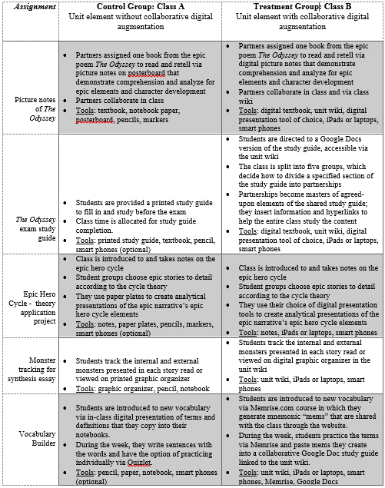

Appendix B
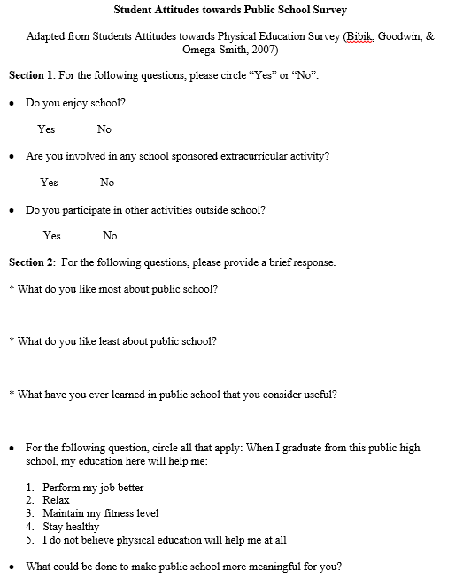
Survey Instrument

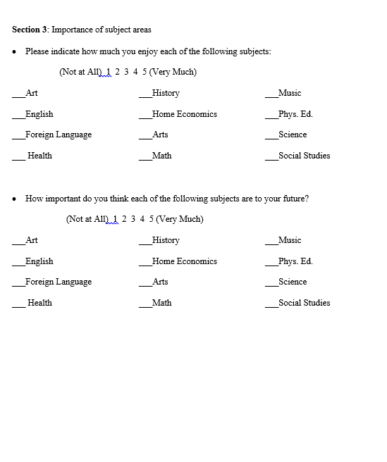

Appendix C
Unit Assessment: The Odyssey Exam
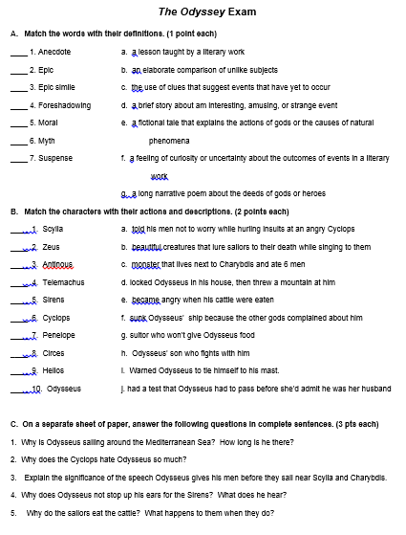
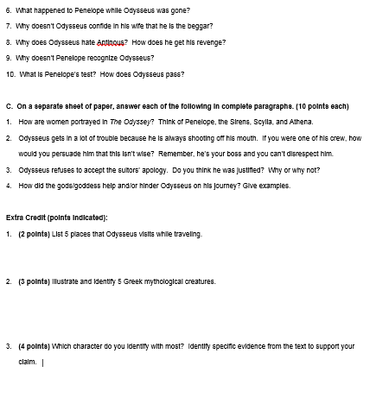

Appendix D
